**ESET 219 Digital Electronics**

Laboratory Report

Lab 6

Flip Flop Circuits

Author: David Ezuma

Due Date: 10/18/2023

All of the information contained in this report is my own work that I completed as part of this lab assignment. I have not used results or content from any unauthorized sources or fellow students.

Ogochukwu Ezuma Date: 11/17/2023

**Introduction**

The objective of task 1 for this lab was to display the timing diagram of a D flip flop circuit. Task 2 required the creation of a circuit of a countdown device. It’s state table was given. the overall purpose of the lab was to examine flip flop behavior and use flip flops in circuit design. The focus on the lab is the D flip flop.

**Background**

A D flip flop works as a state machine, which takes one input and returns an output based on the previous state of the device. It accomplishes this feat through feedback, the configuration of looping its output back to its input, storing said output as a state in memory. To make sense of a D flip flop, a D latch will be explained first. A D latch utilizes an input D, an enable, and feedback to put an output into a set or reset state.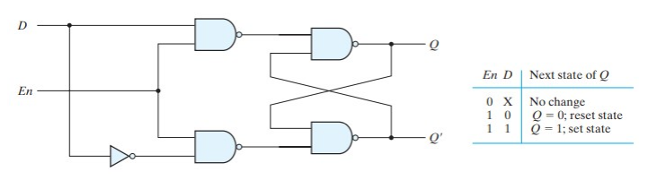

Figure : 0 on the output represents a reset state, while 1 represents a set state

**Implementation**

Describe the lab tasks in detail. What was the problem presented in each task? What items were required to complete each task? What were the constraints or limitations presented in each task?

Describe the methods used to address each of the tasks in lab. Insert figures where necessary. If a table is needed, put a caption above the table at the left hand corner. Insert schematics.

**Results**

Describe the results of each method used to address each of the tasks in lab. Include figures if necessary. If a picture is needed (i.e. picture of FPGA board, DMM, etc.) please make sure the photo is not blurry and easy to understand. Discuss any factors that may have impacted results in a negative way. Insert simulation

**Conclusion**

Summarize the tasks, how you solved them, and results of the task. Discuss problems encountered in each task (if any) and how they were solved.